Note\*

As you noticed that we do not have an investment for the object and the consumption of materials and the salary of an employee because this is a database of construction companies in working hours and this is not a building hierarchy.

The main stages of designing the "Construction company" database:

1. General system design;

2. Designing data structures: selection of fields to include in tables;

3. Designing and linking tables;

4. Designing fields: rules for data entry and validation of their value;

5. Designing queries;

6. Design of forms and reports;

7. Designing automation tools: creating a menu.

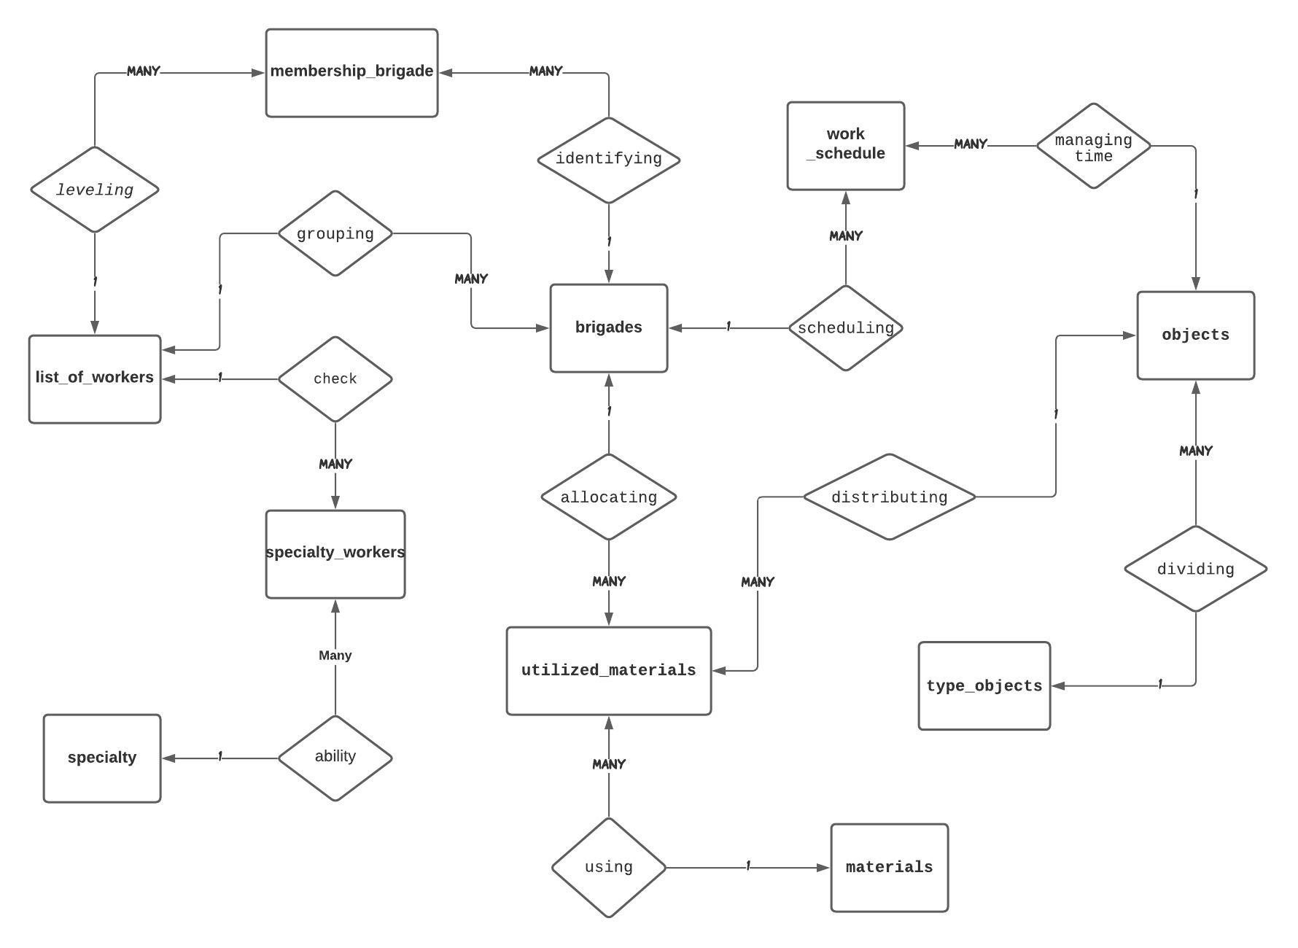

Info logical data model

The Construction Firm database contains the following entities:

1. The entity "Company" - contains information about the company: the name of the company, working hours, address, phone number and full name

2. Entity "Employees" - contains information about employees.

3. The entity "Completed work" - contains the following information: work code, type of work,

4. Essence "Expenses" - contains information about the expenses of clients, namely: type, work, materials.

Business logic

select personnel

The right staff is half the success of your company. If the workers perform their duties efficiently, the company's image will always be at its best.

work schedule - the deadlines for the construction of buildings is very important for a construction company